**AppDev Co.**

UX DESIGN DOCUMENT

By Vibin Varghese

Email: 20096057@mail.wit.ie

Course: MSc in Enterprise Software Systems

April 20, 2022

Table of Contents

1 UX Document 4

1.1 Overview 4

1.2 Description of the Project 4

2 Goal 5

2.1 Purpose of the website 5

2.2 Scope of the website 5

3 Competitor Analysis 6

3.1 Overview of three similar websites 6

3.2 Design features 6

3.2.1 tapadoo.com 6

3.3 Functionality 9

3.3.1 tapadoo.com 9

3.4 Personal opinion 11

4 User Experience 11

4.1 Personas 1 11

4.2 Personas 2 13

4.3 Scenarios 1 – User – Chief Operating Officer 14

4.4 Scenarios 2 – User - App Developer 15

15

5 Content Strategy, Navigation Architecture and Visual Design 16

5.1 Content Inventory 16

5.2 Sitemap 16

5.3 Wireframe Sketches 16

5.4 Wire Frames using a UX Tool (Architectural Blueprints) 16

5.5 Mock-Ups using a UX Tool 16

5.6 Screen Capture 16

6 Evaluation & Testing 17

6.1 Usability Heuristics 17

List of Figures

Fig. 1. Internet of Things Architecture 5

UX Document

Overview

This document provides the details of UX Design of “App Developers Company” website. This document covers the details of the project, purpose of the website(goals), scope of the website, detail analysis of competitor websites. Document will also cover the details of end user, audience definition, scenarios, tools used for designing, navigation architecture & visual design and finally the evaluation and testing of the website.

Description of the Project

**Name:** ‘*AppDev’ Company web design project*

**About the company:** *AppDev is a tech company, which develop app for mobile and software application in web interface. It’s a start-up company with limited customer base. Company creates a unique & high-quality application for all generation with simple and user-friendly interface. The company has been running for a year, working solely on social media and app stores.*

The project is to develop a website for this company. As a start-up, company very new to this business, and will need a web designer to design their brand website. The company have developed and deployed lots of mobile apps which is available for the user to download and use. They also have web view software applications which is sold through enquiry and advertisement. This website needs to handle the user enquiry and show the user about the other mobile applications they have developed. With this the company is looking to grow the business. The website should draw in our target audience – client is looking for something fun and contemporary, yet trendy and sleek at the same time.

Goal

Purpose of the website

Based on Bloom’s Taxonomy Action Verbs, purpose of the website can be set as below.

1. Apply UX design and build a website to show case the apps\services
2. Improve company presence in the market and attracts qualified leads for sales
3. Upcoming projects and informative blogs for the users

Scope of the website

1. ***Apply UX design and build a website to show case the apps\services***

The website for the company required to be unique and the user interaction and expectation is to understand the app, and the services provided. There is certain limitation, since I am using WIX.Com to design and develop the website. The WIX will provide the in-build tools to design, customize and set the color patterns. Also, the limitation of adding different types of pages it allows.

To show case the apps and services, can be made available with the limited scope of WIX tool.

1. ***Improve company presence in the market and attracts qualified leads for sales***

Lead generation is linked directly with the presence of brand in the market. The website must look good, should have good navigation and it must cope with multinational companies. The design tool I use have a limitation to have multi-language support, which can be hosted with region restriction

1. ***Upcoming projects and informative blogs for the users***

The website’s primary purpose is to show case the applications developed by the company in different platform, like mobile and web. Even though the mobile application is published in Google Play Store or an Apple Store, and other website applications are purchased by vast advertisement; An app developer company need to present their product, their vision, customer reviews, top customers, new project, the blogs and the highly skilled team to the world. A website which features all these will help the company to be globally recognized app developer company.

This website also aims to attract qualified leads and allow them to submit their information to the business, who will then follow-up with a sales call. Website is also for informing and educating users; and wants to establish an online presence for themselves to manage their reputation and brand. And provide an online source for their apps to purchase, install and use.

Competitor Analysis

Overview of three similar websites

For the project, I have compared three major app developing companies in Ireland location.

* ***tapadoo.com***

Tapadoo is a mobile app development company based in Dublin. They were founded in 2009 and have a team of 16 employees. They specialize in mobile app development, mobile app modernization, and UX/UI design for clients in healthcare, financial services, and business services industries. They offer a complete app development service; from brainstorming and wireframing, to delivering a pixel perfect finished product. Company takes your app from idea stage, through to development and finally to launching on the app store. They have built apps for the MedTech, Pharmaceuticals, Fintech, Local and National Government, Telecommunications and Wearable Technology. We work with leading brands in Ireland, the UK, US and Canada

* ***squareroot.ie***

Square Root Solutions is a mobile app development company located in Dublin, Ireland. Founded in 2016, they employ between 10 and 49 staff experienced with creating customized mobile applications for a variety of clients. Their expertise covers iOS and Android, game development, VR, IoT, augmented reality, and blockchain. Their Irish and Indian offices work together to ensure all our clients get the most professional and cost-effective experience possible by using Project Management Services of Irish Project Manager and Development Services of Indian Developers.

* ***thecoderspot.ie***

Founded in 2020, The Coder Spot is a mobile app development company. They are headquartered in Dublin, Ireland and have a small team. The company offers mobile app development, web development, application management & support, and custom software development. TheCoderSpot create apps for all platforms, including Android app development, iOS app development, Windows, and more. In addition, we can handle the entire process from developing the idea to creating the designs for user interface and user experience to writing the code to getting the app launched on the Apple app store, Google Play Store, and Windows app store.

Design features

### tapadoo.com

* **Pro’s**
* *All device compatible:* Site designed is compatible for all type of devices including mobile, tablet and web.

|  |  |
| --- | --- |
|  |  |
| Mobile\Tab View | WebView |

* *Color schema:* The site used mainly dark and wite color schema in all the pages, with few bright colours.

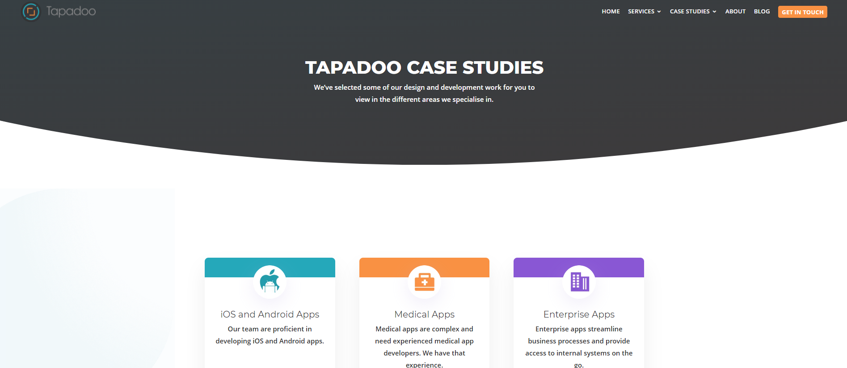

* *Fonts and Layout:*All the fonts and layout structure are same in all the pages

|  |  |
| --- | --- |
|  |  |

* *Contact Info:* Form to contact the company is available in all the pages

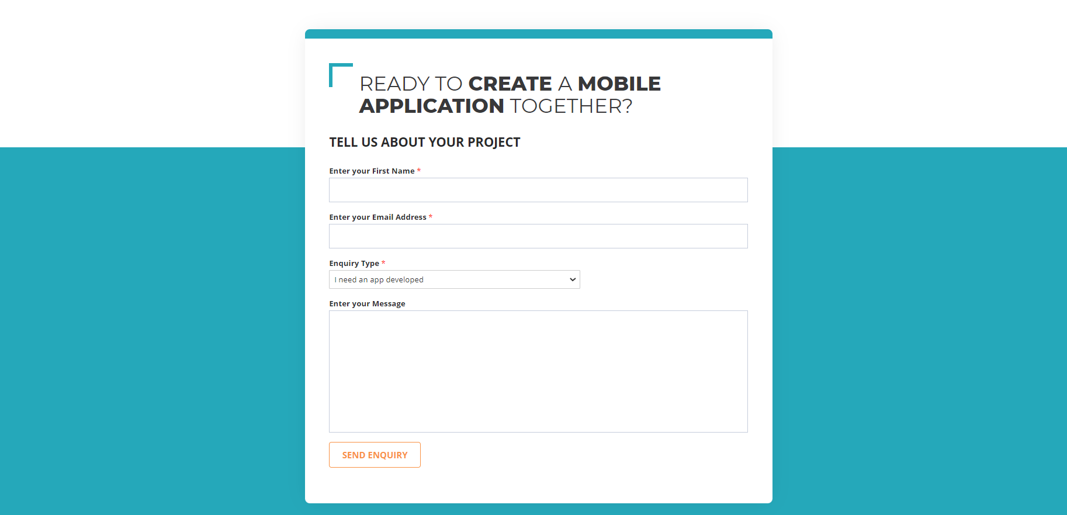

* *Simple Design:* Website is simple and understandable to all the users, no complicated structure or layout
* **Con’s**
* *Misaligned layout structure:* In few of the pages, the header strip is not in proper aligned or sized. Difference is red marked in circle in the below image.

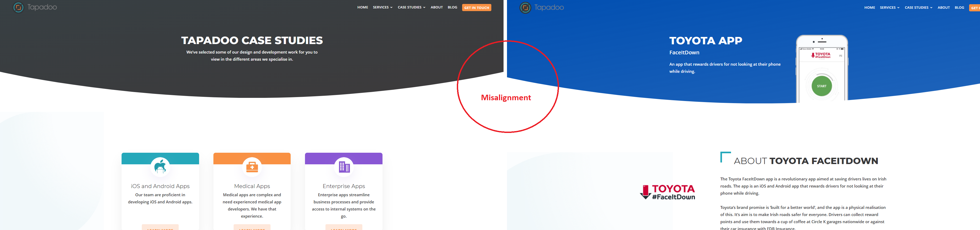

* 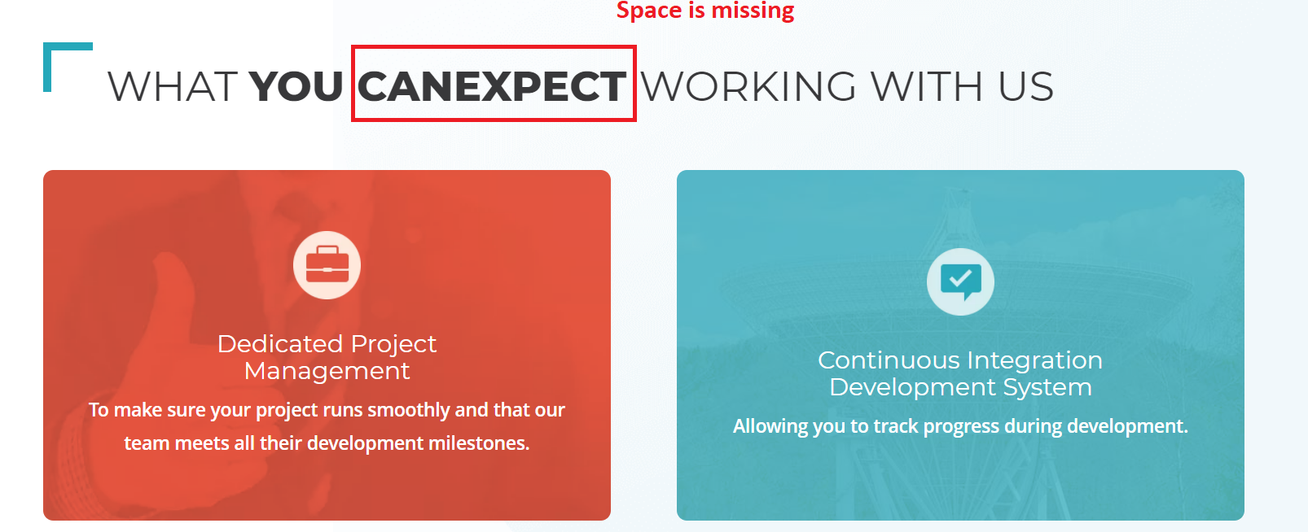*Wording issue:* Check the below image, “CAN EXPECT” have no space in some pages.
* *Code Error:* Error in the HTML code in visible in the we side all pages, which is shown in the footer of the webpage. Also, error in Quick calculator, in some occasions return to previous page does not work Check the red marked in the below image

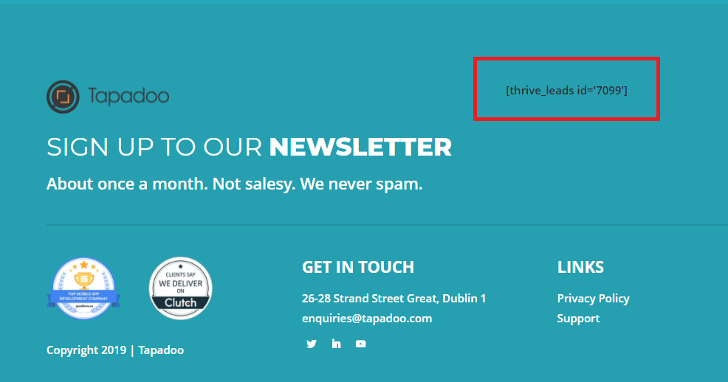

* *Link Broken:* Button in the home to open the contact details is broken in the website. Red marked in the below image.

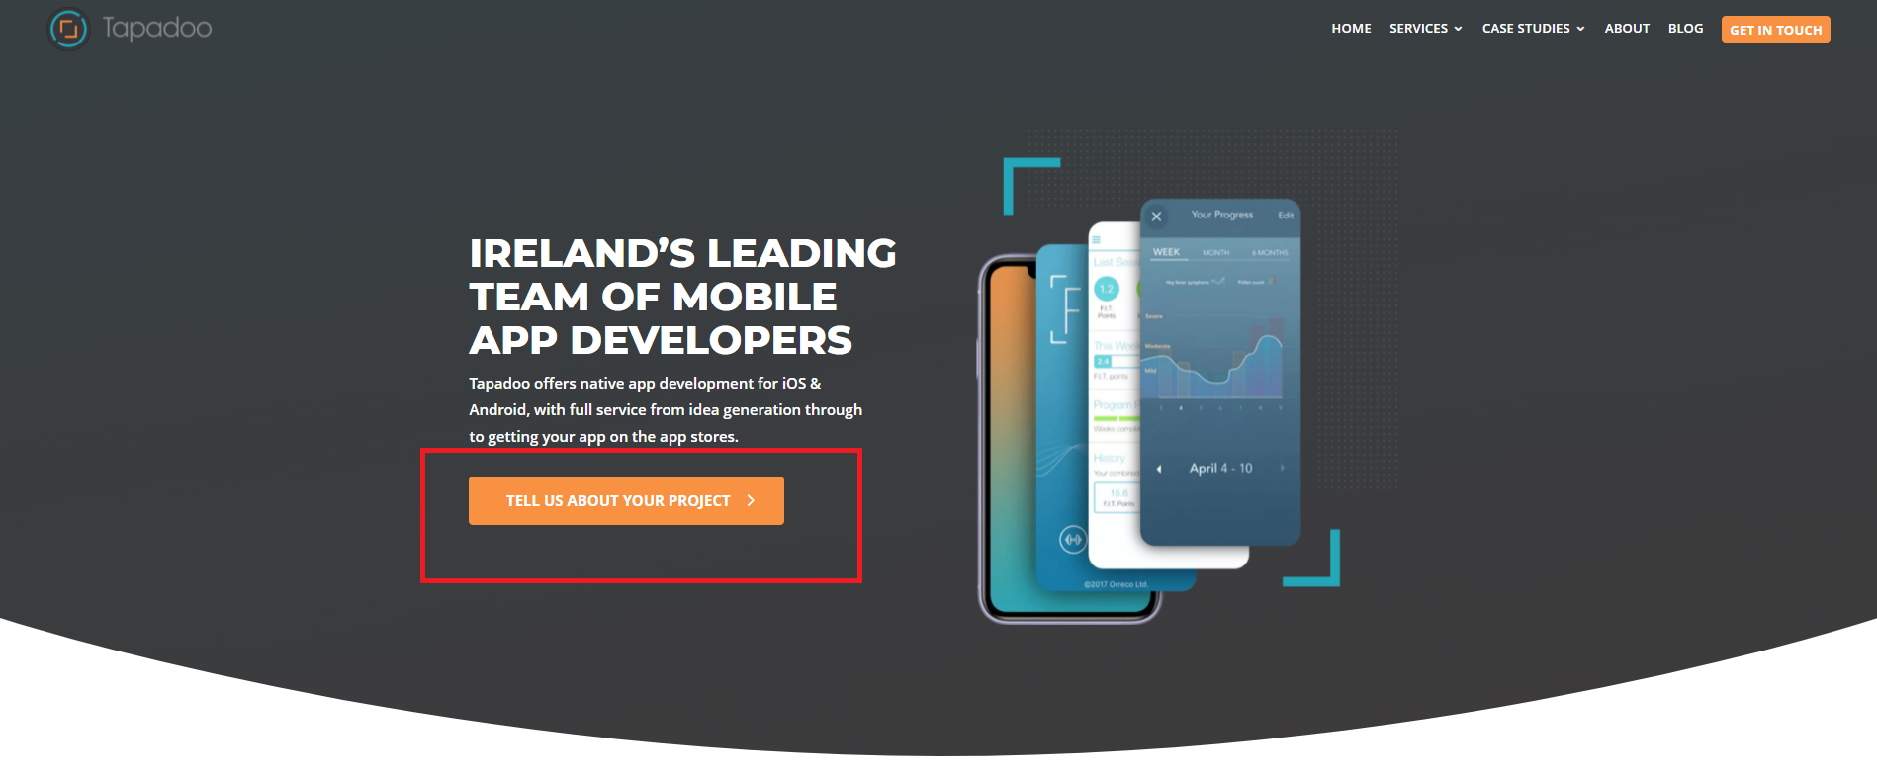

* *Code Error:* Error in Quick calculator, in some occasions return to previous page does not work Check the red marked area in the below image.

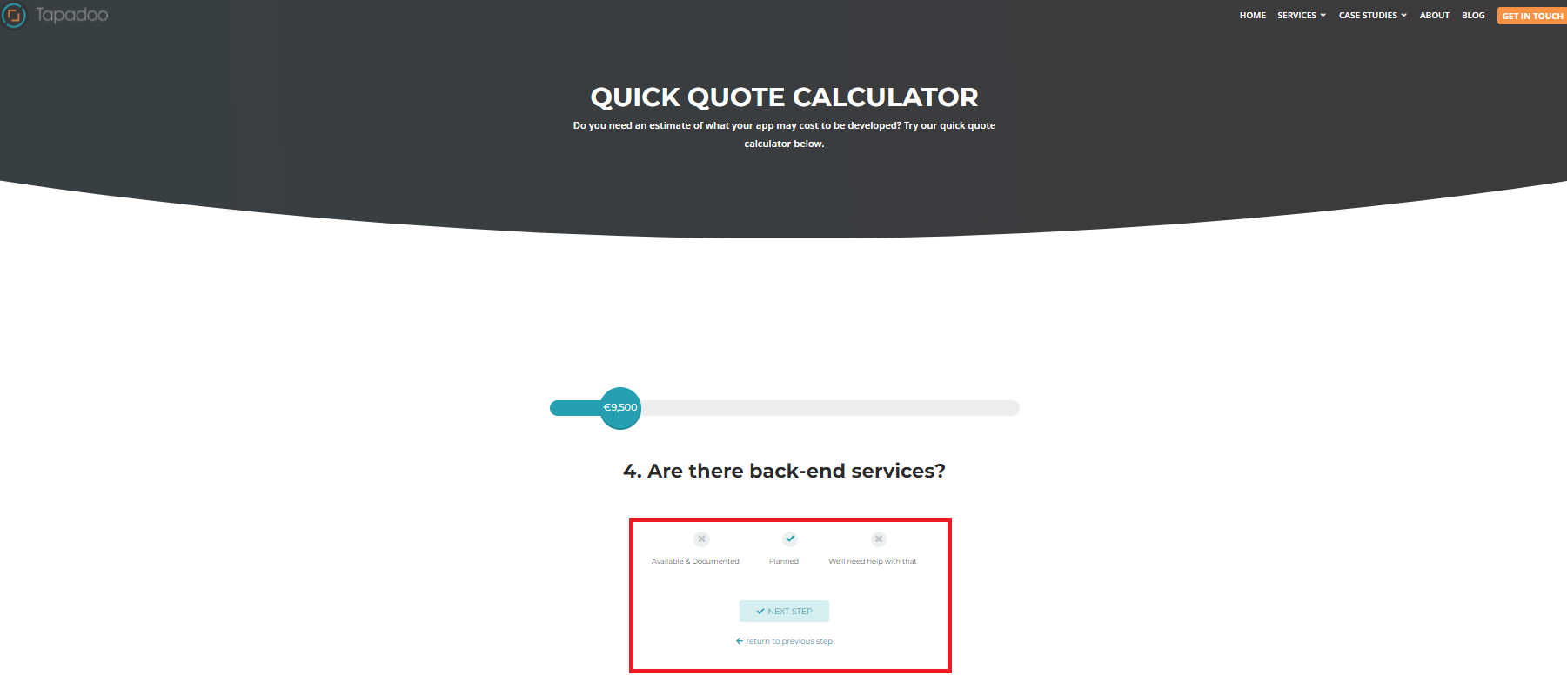

### squareroot.ie

* **Pro’s**
* *All device compatible:* Site designed is compatible for all type of devices including mobile, tablet and web.

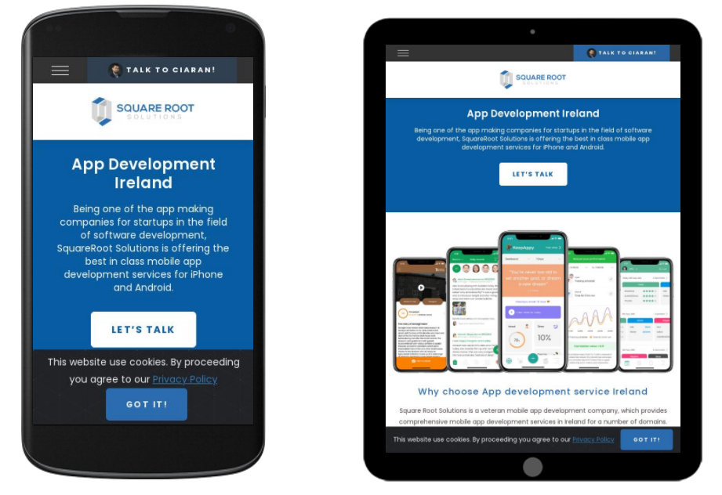

* *Quality of image and alignment:* All the pages in the website uses very good quality image and is prefect choices of image for all the topic it covers. All the strips, images, card views are perfectly aligned in all the pages.
* 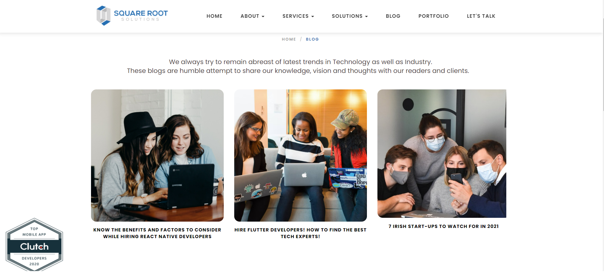*Structured Navigation:* Navigation menu is set in order, so that user can go though in an order to understand the company, there services and the solutions they provide, and finally to get in touch with them after understand the company.



* *Color patterns:* For a technology company, Navy Blue and White as primary color is a perfect choice. Blue evokes reliability and competence and brings attention to the innovative nature of the products.

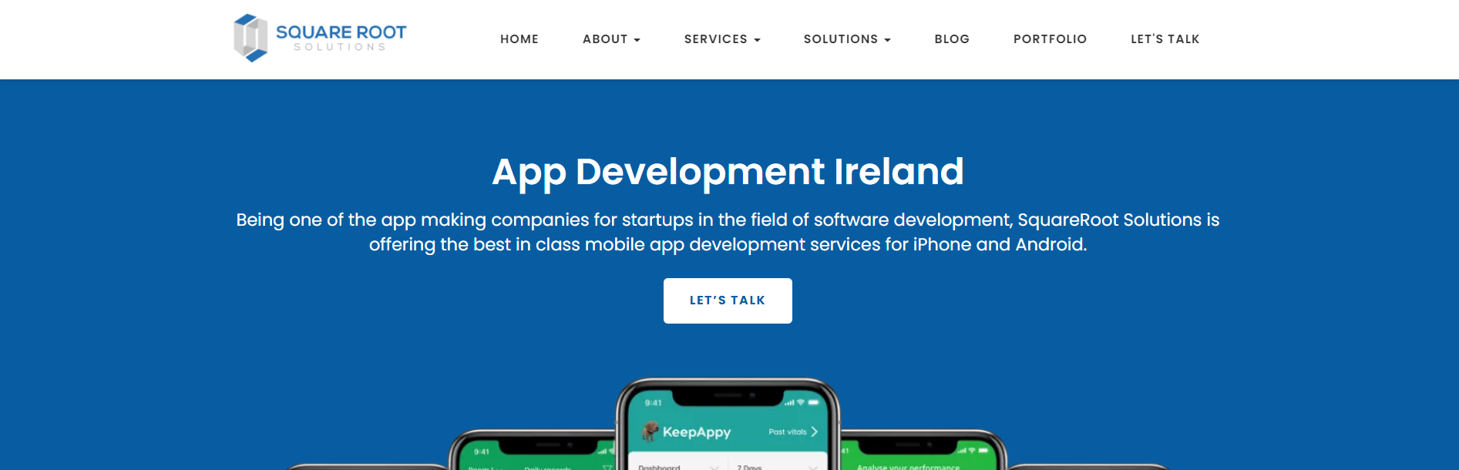

* *Awards and Branding*: Recent awards received by the company is pinned to the left side bottom corner for the pages (even on page scroll). And other major awards are been listed in footer of the pages. They try to brand their self to the world by showing the success they have in these years

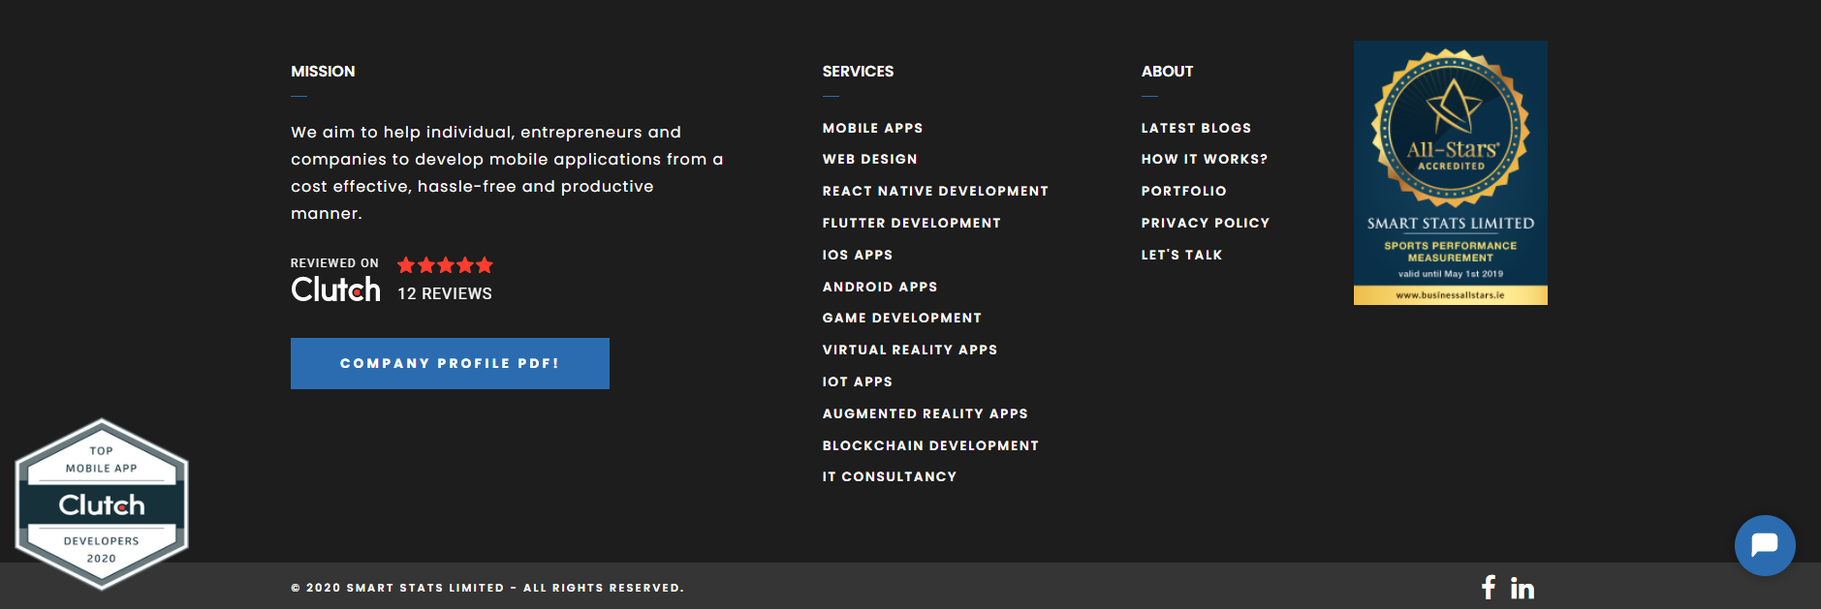

* **Con’s**
* *Awards and Branding*: This was done for brand their self to the world by showing the success they have in these years. But the Awards, which is pinned in all the pages covers the actual content in the page, we can notice that in the below image.

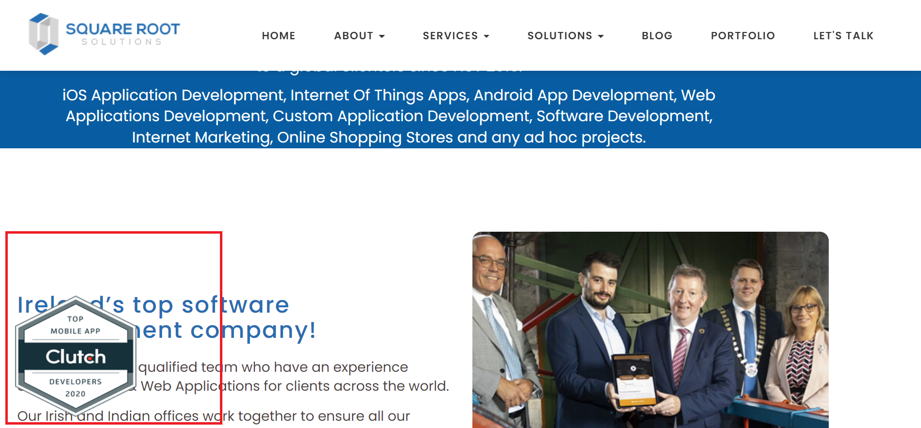

* *Text Alignment:* In the about us page of the website, the content details are not aligned, we can notice the difference in the spacing in the page. Check the image below, where it is marked in red.

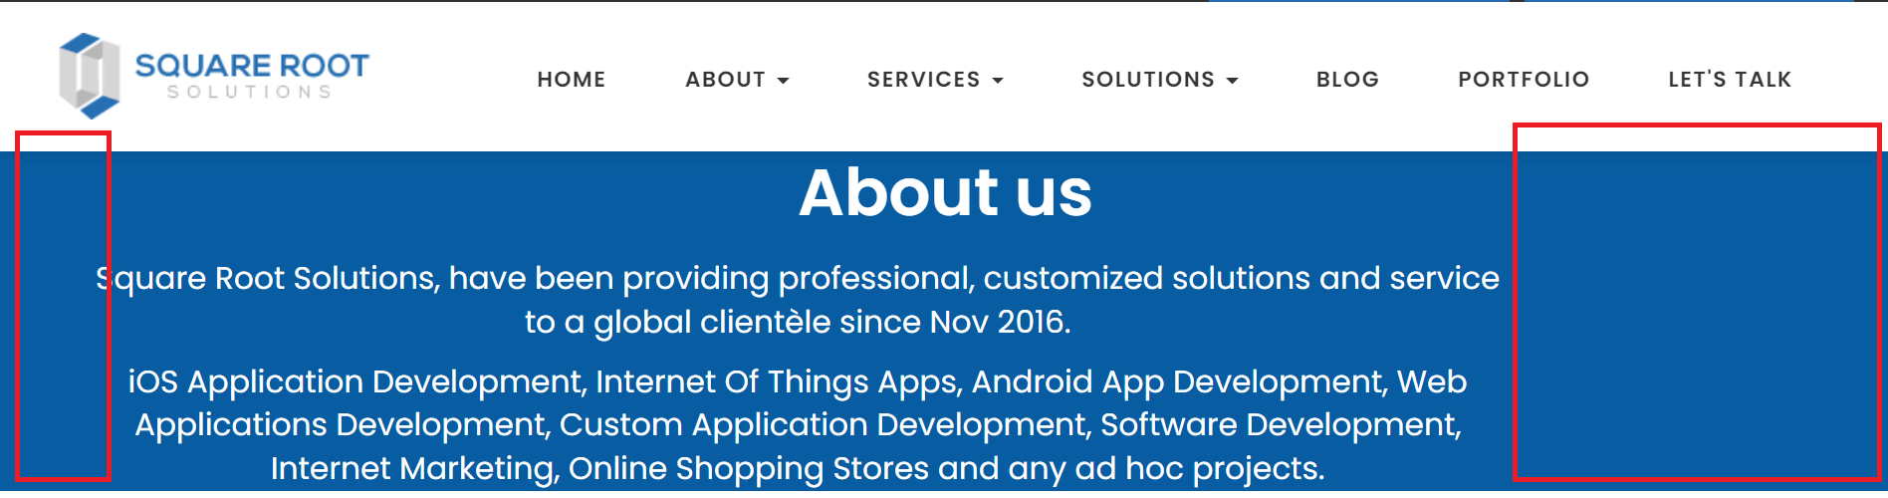

* 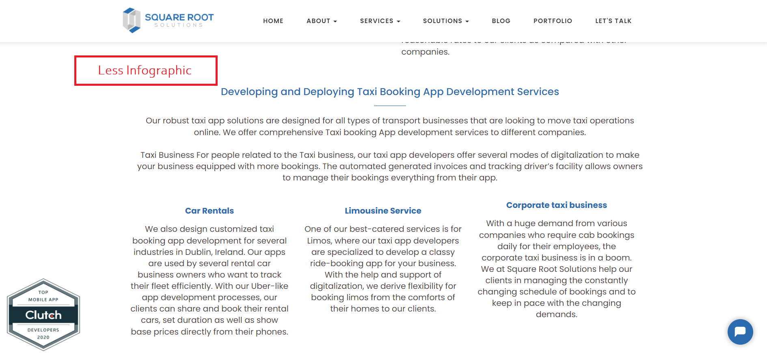*Less Infographics:* Like most of the technology related company website, this web site used more text data than infographic data. This website cannot be scanned, means users cannot get the idea of the content by simply scanned to the website, since they have to read lots of data to understand the details.
* *Line spacing:* In most of the paged in the website have this line spacing problem. Few lines are skipped in the page content. We can notice that in the below image.

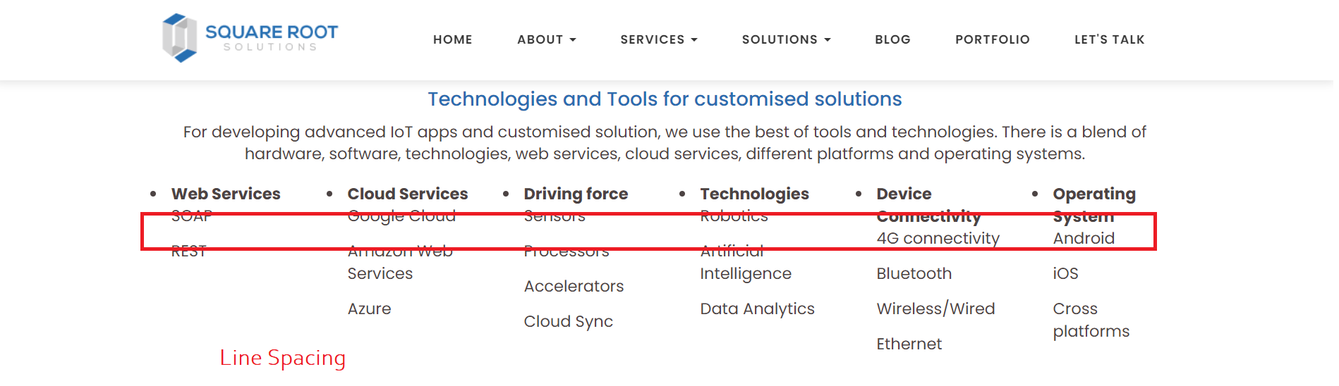

* *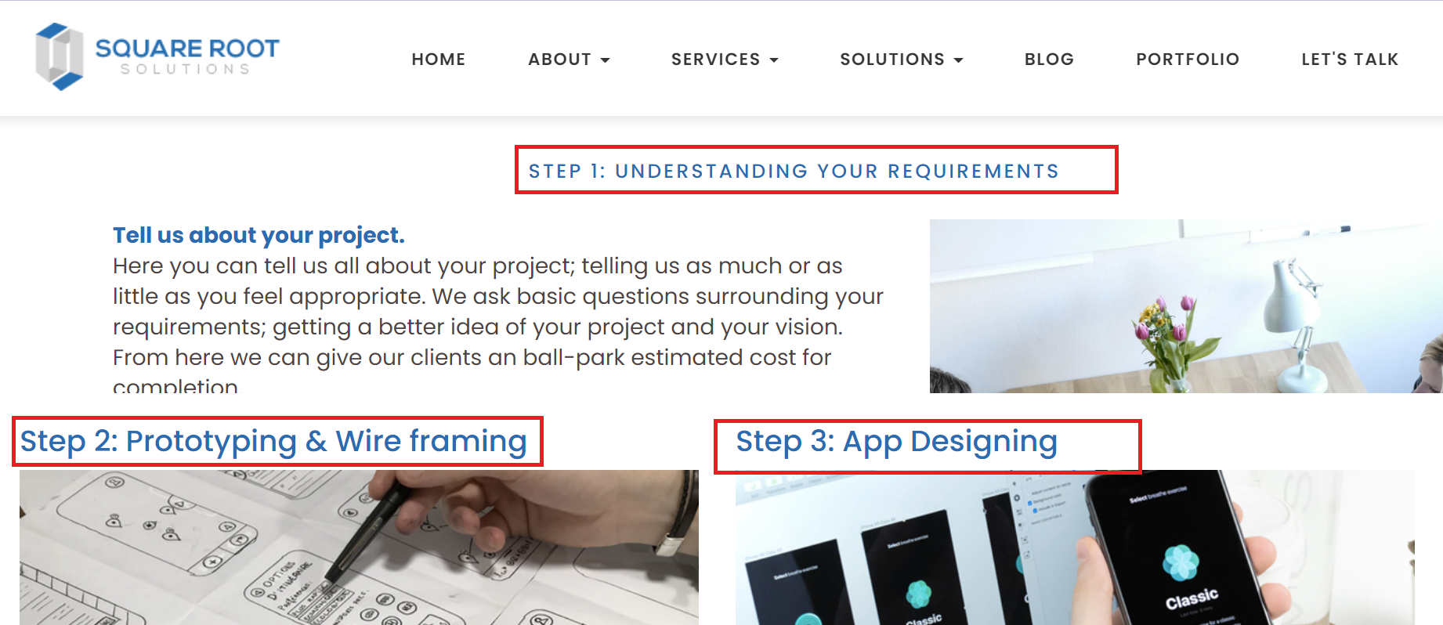Font Size:* Check the below image, page explains the steps of development process. In the page, for the steps they have used multiple fonts. Size of step 1 is small and its increases in the step 2,3. These problems are available in few of the pages.
* *ToolTip:* Tools tip is enabled on few places in the webpage for ser understanding, but the tool tip values mapped is completely wrong in all the places. We can notice in the image, for email tool tip is showing as phone.

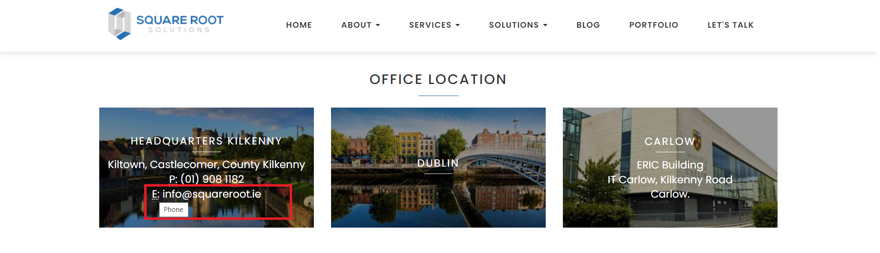

### thecoderspot.ie

* **Pro’s**
* 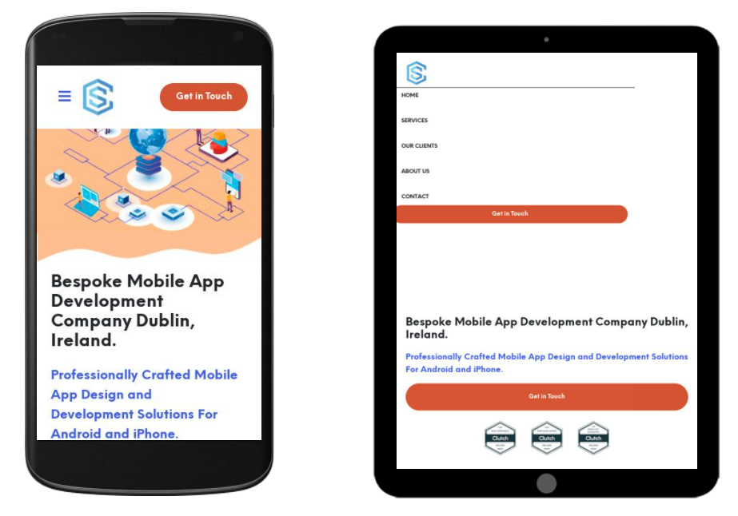*All device compatible:* Site designed is compatible for all type of devices including mobile, tablet and web.
* *Structured well:* Navigation menu is simple and easy to navigate in the website. Contact the company option is given in the menu and also in the home page. They have set the awards and social media details in the home itself for user to understand and contact the company.

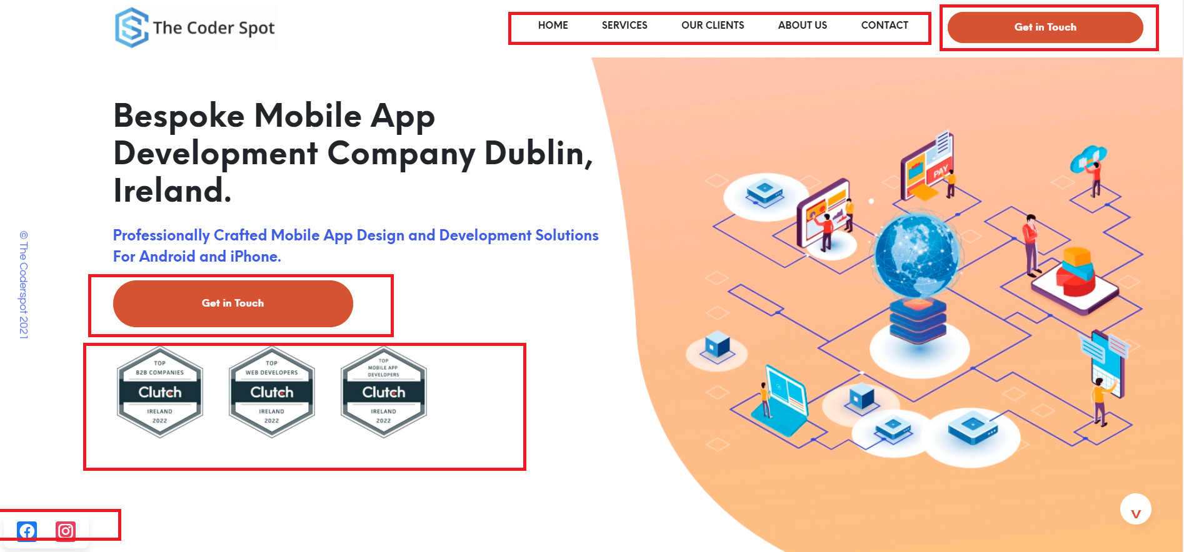

* *Client details:* Not like other company website, this website have listed the company with logo and given external access to those company website. This help to understand the clients and their details in a easy manner.

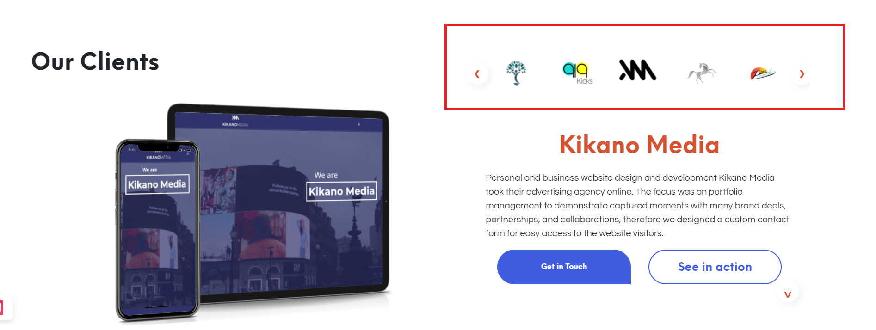

* *Unique menu:* Other than the main navigation menu, website have given ad side menu in few of the pages, which acts as a bookmark to the content in the page. This is very helpful for the user to navigate to the page by looking in to the heading mention in this side menu.

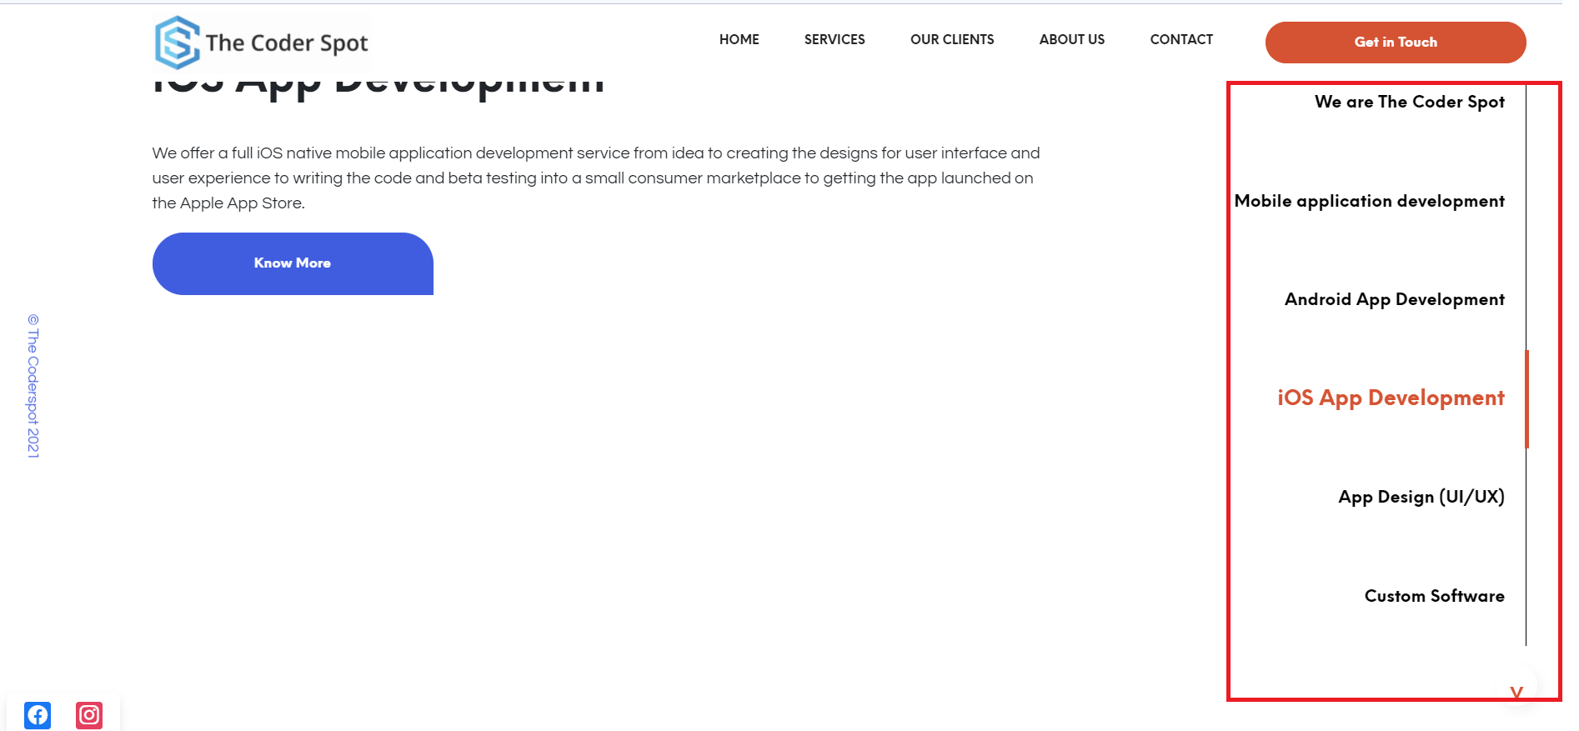

* **Con’s**

Like other two website, this website has very limited Cons, but are major

* 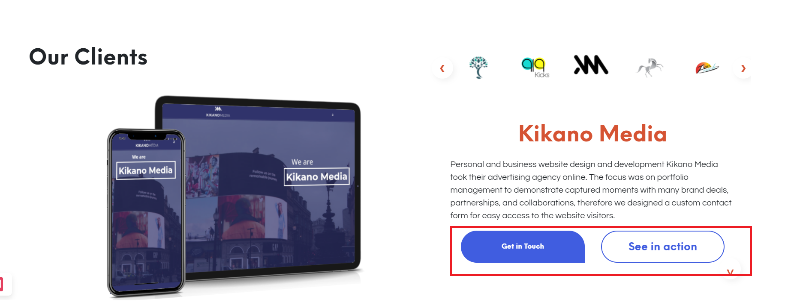*Button Style:* In the client details page, the two button have two different styles. Both the button is accessing a page inside the website.
* 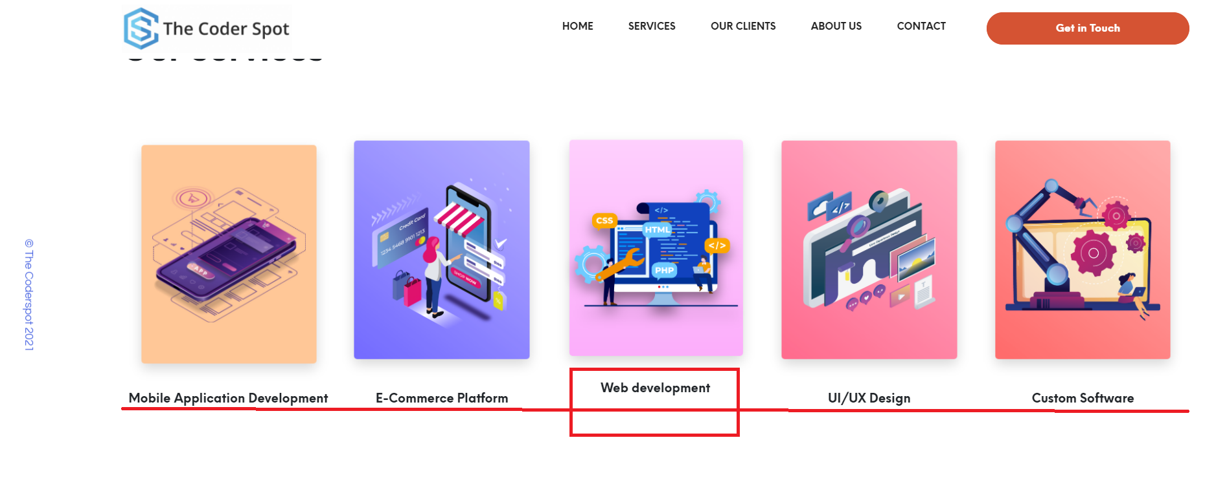*Alignment problem:* In two pages, the alignment is off. We can notice that in contact us page and development page.

|  |  |  |
| --- | --- | --- |
| **tapadoo.com** | **squareroot.ie** | **thecoderspot.ie** |
|  | * Not mobile view compatible * More complex design * Navy Blue and white color combination * It’s a readable website, lots of text and with less infographic * Unprofessional layout structure and different text style in some pages * Not clear about the website audience | * Main page is mobile view compatible * Simple design for all age group * Multi color patterns and mainly used white * More infographic and visual website * Graphics, layout, text, and interactive elements works perfect * Very clear understanding of the audience and their requirement |

Functionality

### tapadoo.com

* **Pro’s**
* *Menu Navigation:* Service menu is structured with sub menus with clear idea of services. Case study also have sub menu with major case study details.

|  |  |  |
| --- | --- | --- |
|  |  |  |

* 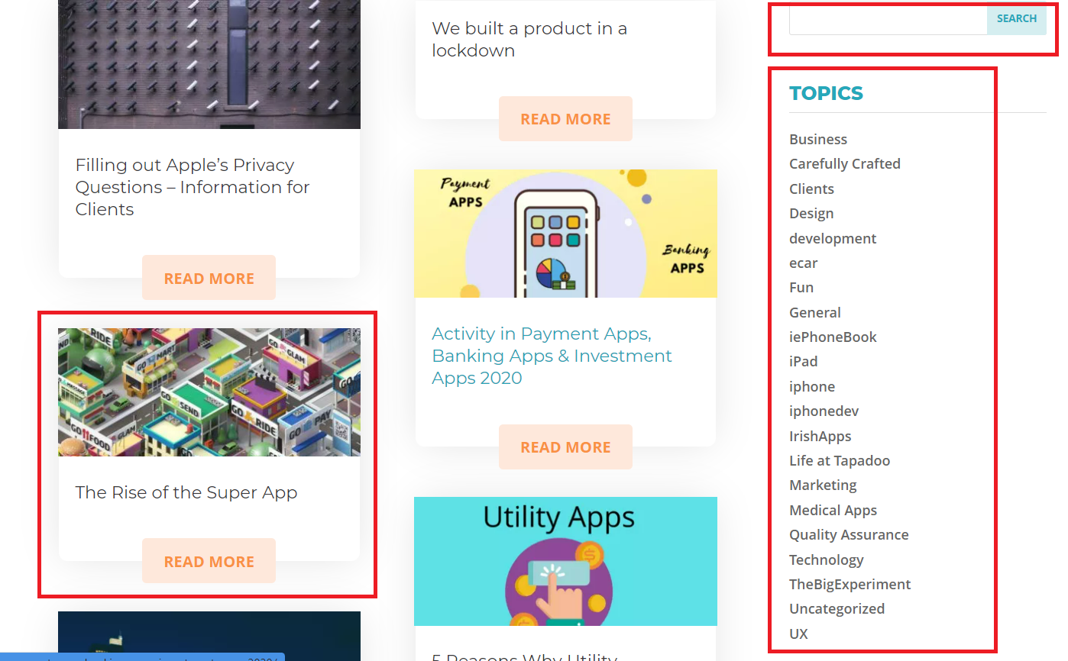*Blogs:* Added blogs with good list of topics for the user, this page include blog search for easy access to the user.
* *Development Cost:* Quick quote calculator function is given to the user to estimate the development cost of an application.

|  |  |  |
| --- | --- | --- |
|  |  |  |

* **Con’s**
* *Search Option:* Search is enabled inside the blog page only, not for searching the app or any other content. Check the red marked in the below image
* Personal Chat option is not given for user to quick assistance. Social media branding and sharing is not provided in any pages of website.

---------------- -- -- **squareroot.ie** - -------------------------

Fun PRO

On time Chat and cntanct support

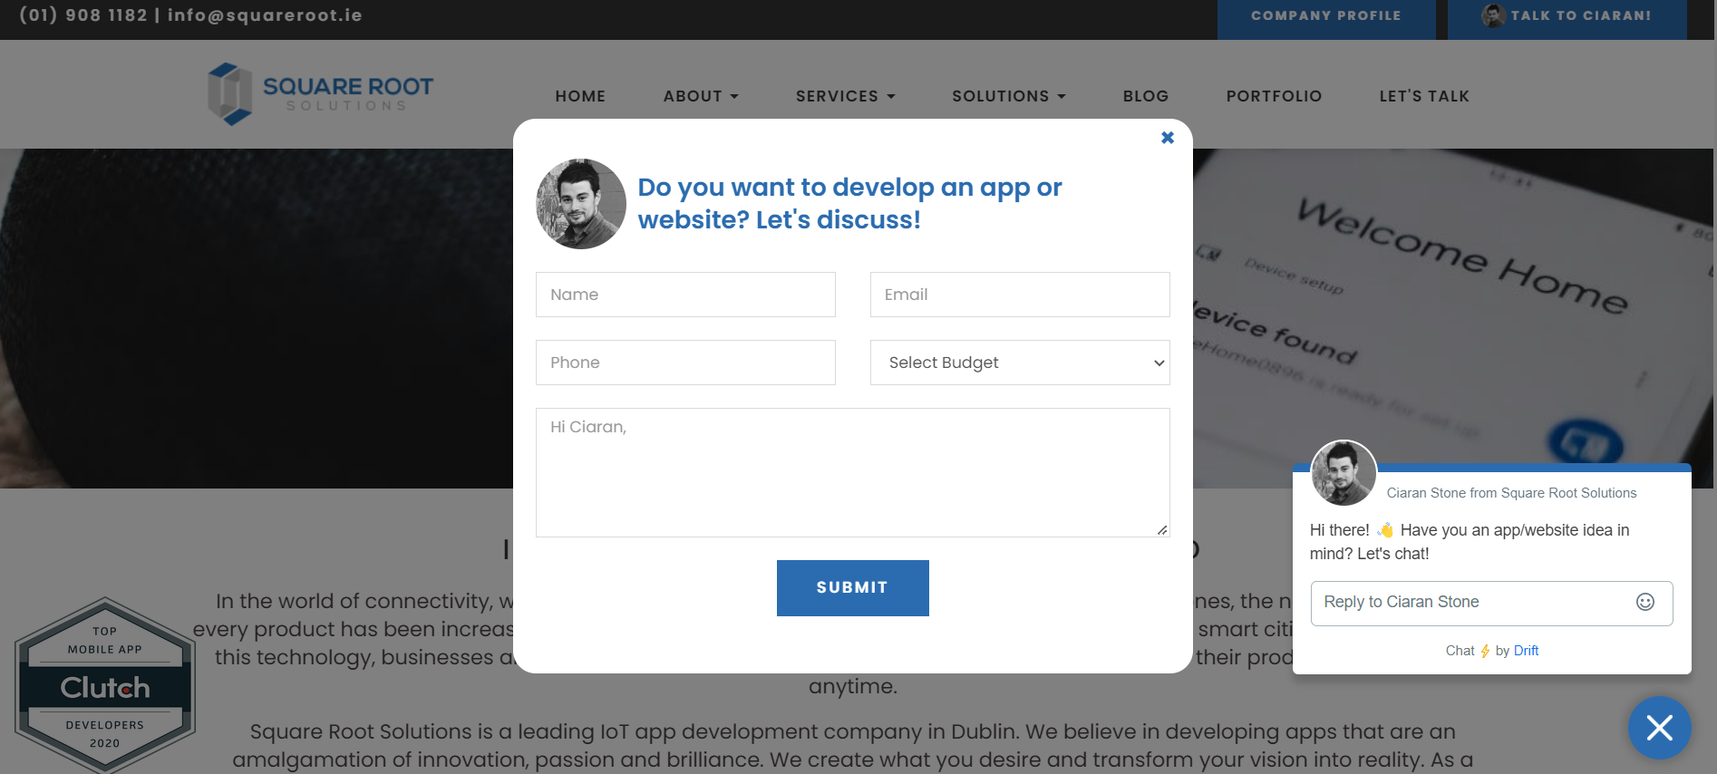

Company profile PDF avalible in two clocation and pdf have detail comple details

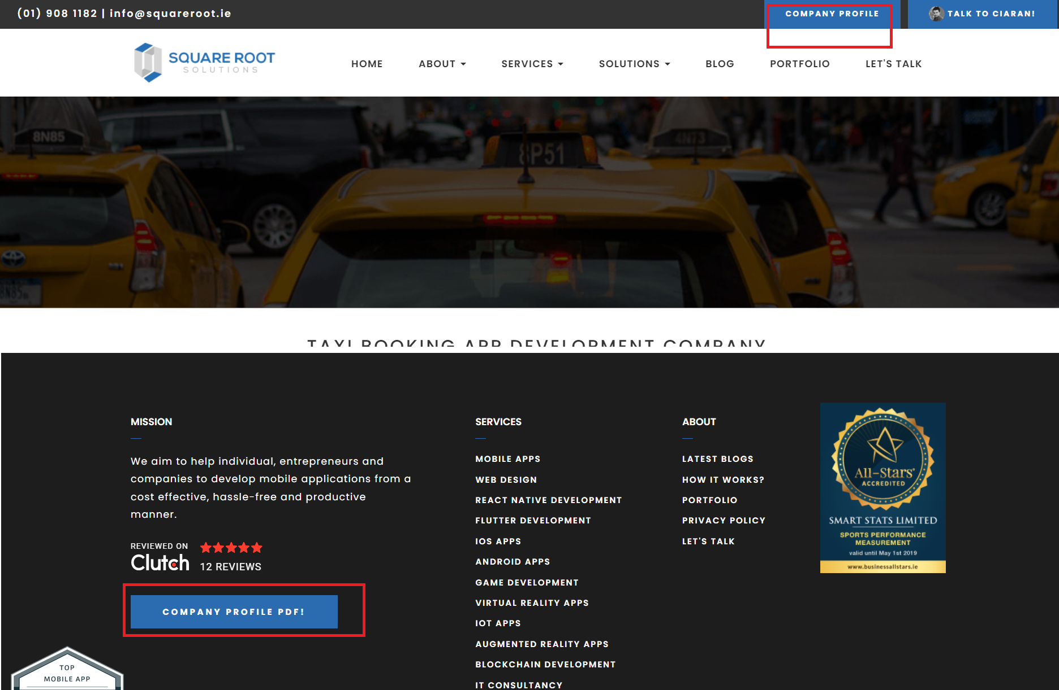

Budget is asked in the contact details

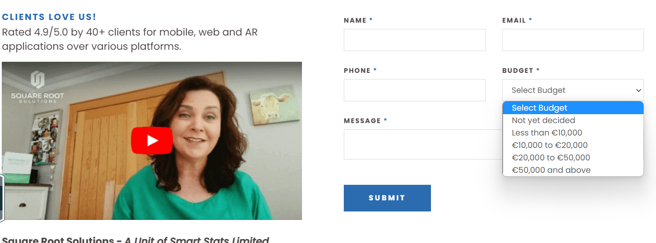

FUN CONS

Complicated navigation and not easy to find the details

In-site search not available

Blogs are not frequently created and updated

Categorized App library for easy search

Not provide any details of location or address

=------------------------- **thecoderspot.ie** ------------------------------

FUN PRO

Three step procee with details for contact

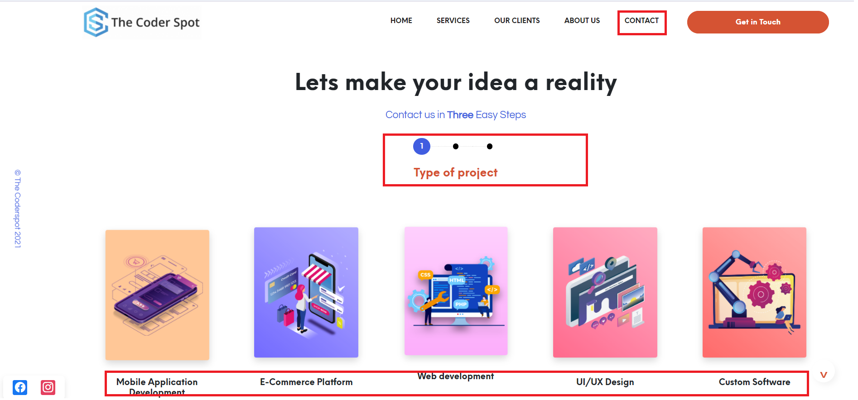

See in action for any app or website link

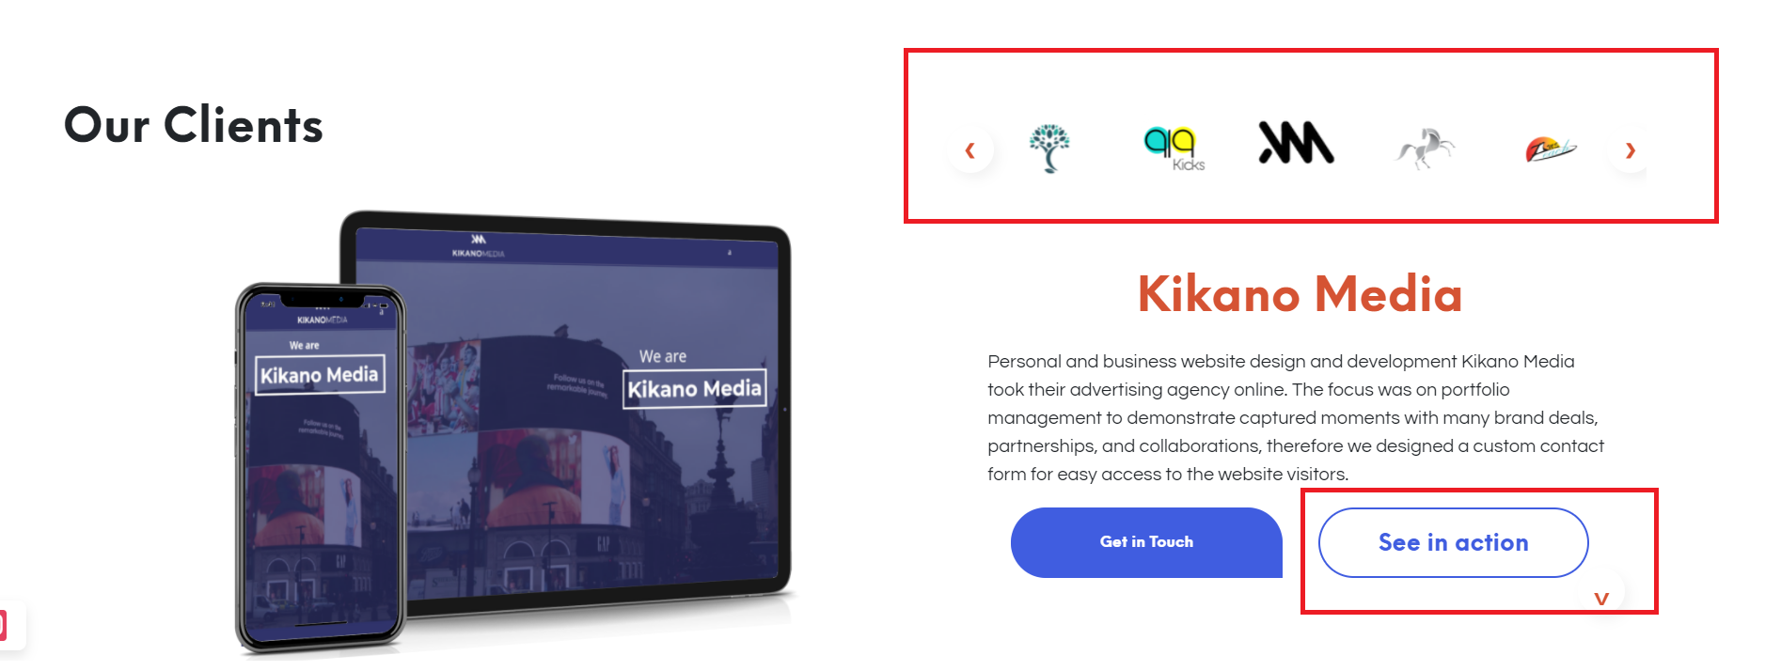

Post application Idea

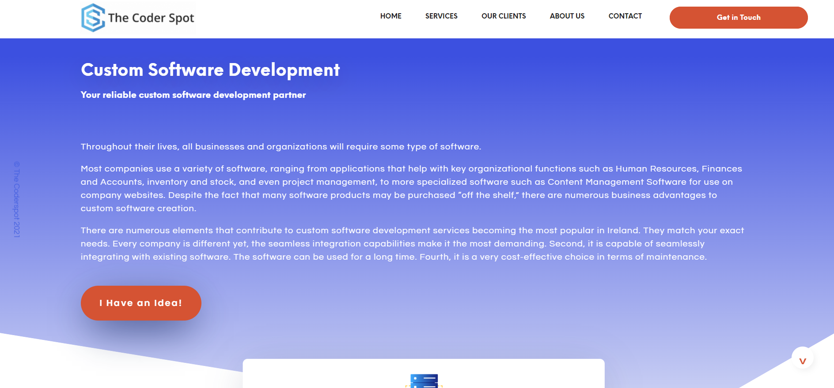

COS

No blog

* In-site search not available
* No Blog/news for the site
* No App library, Only the services are mentioned
* No options for chat
* Searching for content is not available

|  |  |  |
| --- | --- | --- |
| **tapadoo.com** | **squareroot.ie** | **thecoderspot.ie** |
|  |  | * Graphical Navigation with simple navigation flow * In-site search not available * No Blog/news for the site * No App library, Only the services are mentioned * No options for chat * Searching for content is not available * Contact form is given after filter of service, type of device and budget amount is selected. * Limited details in calendar about new product launch * Social sharing tool for the website * Office address Location is given in home page |

Personal opinion

### tapadoo.com

The website has given a clear idea about the product and services to the audience. Website is structured well and navigation is simple, so that all generation users can use the website well. Good branding of company and products with short in dept description of the product is provide in the website. Most important case studies are given in details. The estimate calculation is one of the major highlights of the website, which is unique to most of the similar website.

But website lacks to giving the user reviews, achievements of the company. There are some very basic design issues, and missing a search functionality of the website.

Over all a simple and elegant website with good future thoughts.

|  |  |  |
| --- | --- | --- |
| **tapadoo.com** | **squareroot.ie** | **thecoderspot.ie** |
|  | * This website cannot be scanned, too much of text and less use of infographic. It is very hard to find products and details * Design felt dull, not suitable for a tech company. Website looks more like a software to navigate through * They have tried to brand the website in a way, which annoy the audience by pin down the awards in all pages * Over all, app portfolio page is well structured, but other pages are complicated. | * Infographics is used in most of the areas to get audience attention, rather than the text. * Its is easy for any user to navigate through the site and keep the audience in the website. * A well-designed website, but limited so may functionality which is required for branding and expanding the company. * Over all, designed with high value but lacks the purpose of the website. |

User Experience

Personas 1

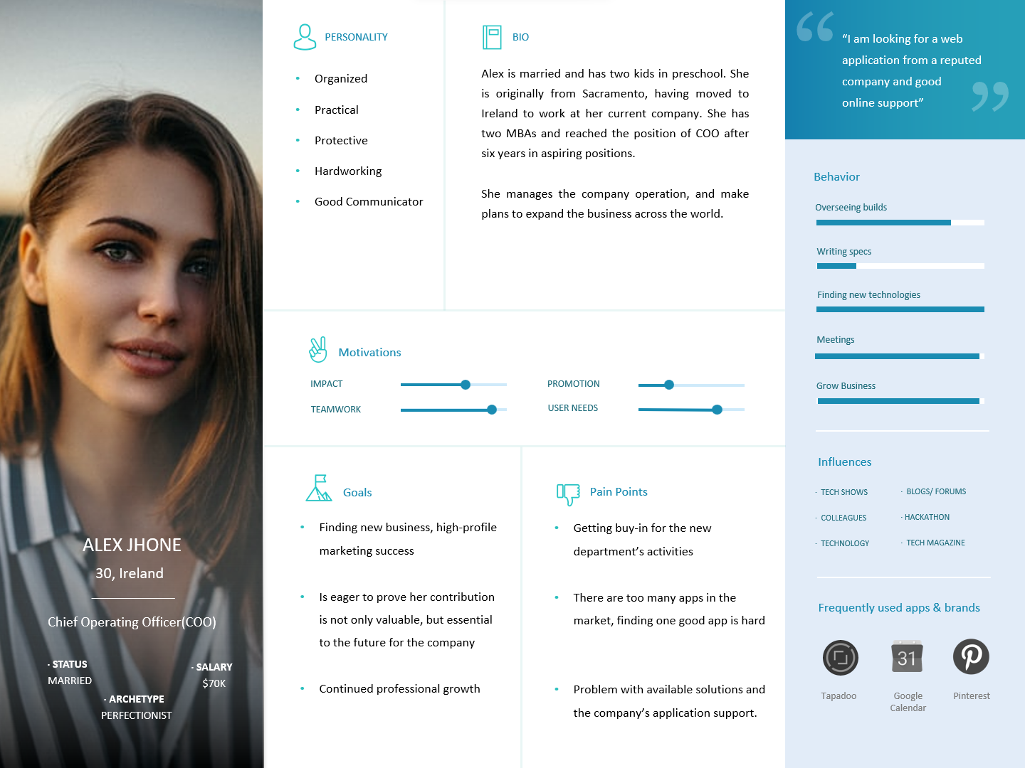

Personas 2

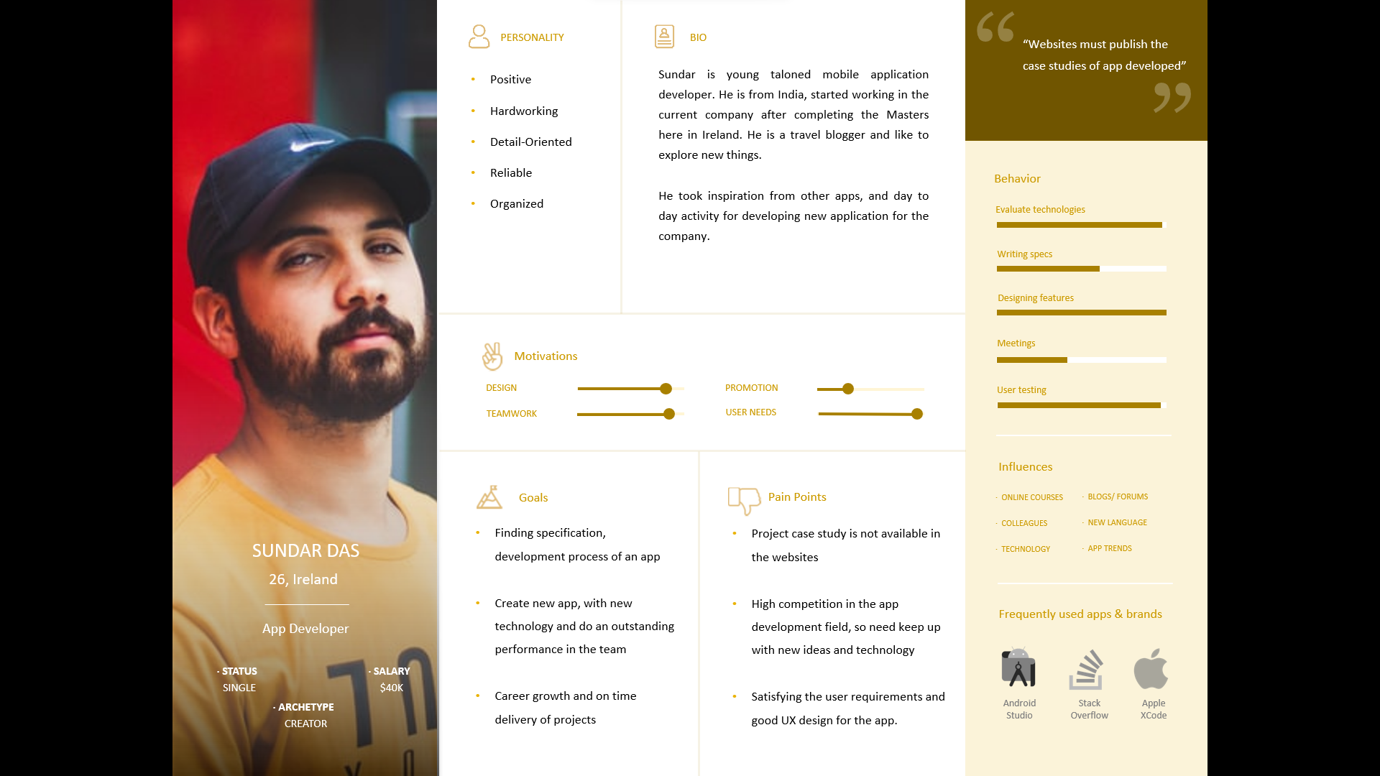

Scenarios 1 – User – Chief Operating Officer

Alex Jhone is a COO of a reputed company; she is looking for a web application for the company she works for. She is searching web application details form the developer’s website which have good reputation and support for the application

* Alex is searching for a web application to manage here company’s HR process. She started googling for the application.
* She found a company website, which provides the HR Solution and it’s a web application.
* She opens the web app section and search for HR Application
* Then she checks the features in the application in detail including the support they provide online after purchase. Will she check the pricing of the application?
* She wants to know the team behind the company and the clients associated with them. Will she able to find the team behind the company and their clients?
* She moved on to contact section to get in touch with the company for the purchase of the app.

**Alex Jhone – Chief Operating Officer**

Wants to purchase an HR web application from a reputed company with good after purchase support.

Access the website URL

Search for the app to buy

Select the app

Check the app specification and support

Check the team and associated clients

Send an enquiry to the company for purchasing app

How did she know about the website?

What key did she used to find the website in Google?

How does she select the app? Is there any factor involved in it?

Is she able to find all the details she was looking for?

Did she check any screen shots of the app?

Does she able to find the team members and client details easily?

How does she found out to contact the company for enquiry?

A short app description of app can be provided before the opening app page

We need to show the specification with support details

Management and development team details to be included in about us section

We can show Highlighted apps in the home page

In-page search option in home page will be helpful to find app so easily

A quick view option with Summary of the app page

App Details page with all the specification, support with Screen shot of app

About Us page with company story, Team members with details and the clients list with external link.

Reach out should be set in all pages, so the user can send the enquiry at any point of time.

Steps

Question

Comments

Idea

Key

We need to focus on search keyword to become more visible

Is the app easy to find?

Scenarios 2 – User - App Developer

Sundar Das is a mobile application developer, who is more interested in understanding the process of development of some unique apps.

* Sundar was browsing through the google pay store, found an app which have some good functionality and good design. He wants to know the requirement and case study about the app.
* In the app developer company website address is mentioned in the paly store description.
* He opens the company website and started looking for the list of apps developed by the company.
* Goes through the company website and finds the portfolio details.
* In the navigation menu, what does he found? He finds device wise sub set of menus.
* He selected the android app list from the list, Since the app was listed in the google paly store.
* By search through the page, he found the app with case study. How about downloading the case study? Is any specification or the audience details specified in the page?



Sundar finds a new app in Google play store

He navigates to the app developer website

In the website he is navigating to find the app portfolio of apps

He filters the device type listed in the website

Then he searches for the app inside the filtered list

He saw the app with case study in the website

Will Sundar know the app website?

Is the website have the navigation to list of apps developed by them?

Will he be able to filter the device (web, android, apple)?

The app he saw in play store is listed in the portfolio?

What sort of information will he wants to know?

We need to have a navigation menu specifically for the app portfolio

We will probably want to add sub menus to select the device

We will need to add a filter or search for the page

We need to show the specification, requirement details and case study details

We want to show the navigation in the website

We could provide a detail navigation menu

We could add a menu specifically for portfolio

A portfolio menu could be sub categorized to different device menu

Can show a filter or a search option in the device wise app portfolio page

In details case study could be displayed with a downloadable document

Steps

Question

Comments

Idea

Key

**Sundar Das – App developer**

Looking for the case study of an app he saw in google pay store

Content Strategy, Navigation Architecture and Visual Design

Content Inventory

|  |  |  |  |  |  |  |  |
| --- | --- | --- | --- | --- | --- | --- | --- |
|  | **Navigation title** | **Page title** | **Breakdown of Headings/Sub-headings** | **Last updated** | **Owner** | **Comments** | **Delete?** |
| 0.0 | Home | Home |  |  |  |  |  |
| 1.0 | Portfolio |  |  |  |  | No page at this level |  |
| 1.1 | Web View Application | Web View Application | 1 PDF for each project |  |  |  |  |
| 1.2 | Android Application | Android Application | 1 PDF for each project |  |  |  |  |
| 1.3 | IOS Application | IOS Application | 1 PDF for each project |  |  |  |  |
| 2.0 | Technologies | Technologies |  |  |  |  |  |
| 3.0 | Awards | Awards |  |  |  |  |  |
| 4.0 | About | About |  |  |  |  |  |
| 5.0 | Contact | Contact |  |  |  | Email address & contact form |  |
| 6.0 | [Plans & Pricing](http://www.winetasmania.com.au/contact) | [Plans & Pricing](http://www.winetasmania.com.au/contact) |  |  |  |  |  |
| 7.0 | Blog | Blog |  |  |  |  |  |

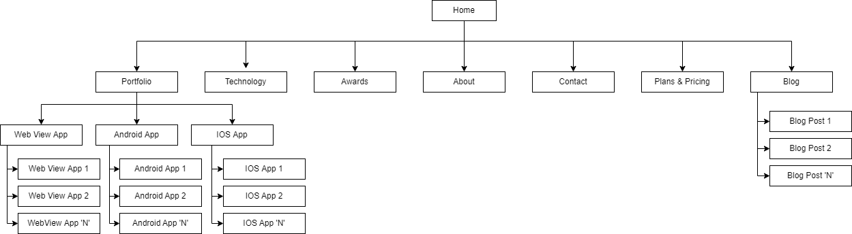Sitemap

Wireframe Sketches

Wire Frames using a UX Tool (Architectural Blueprints)

Mock-Ups using a UX Tool

Screen Capture

Evaluation & Testing

Usability Heuristics